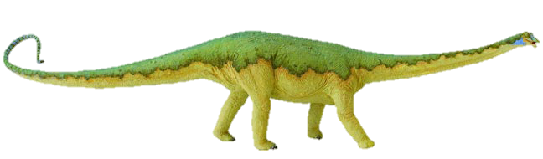
Long and short i sound sort
Sometimes it’s helpful to say that short sounds are short and bouncy, and to make a bouncing ball action as you say them; while long sounds can be stretched, exaggerating the sound slightly, whilst making a stretching elastic kind of movement.
Cut this top row off before you give the sort to pupils!

long vowel |  | 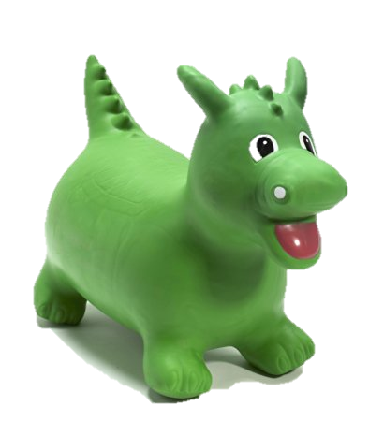  short  vowel
Sort by long or short sound – helps children to look for the single short a grapheme or to see it in combination with other letters to make a digraph with a long sound. | 
miss | bike | high
hi | tight | fly
my | by | dig
pig | sit | six
bite | kite | sigh
knight | smile | lie
untie | dried | magpie
lighter | fight | cry
apply | zip | pin
fix | tig | big
fig | lipstick | jig

